**Ex No 1**

**Downloading and installing Hadoop on Mac, Understanding different Hadoop modes, Startup scripts, Configuration files.**

**AIM:**

**To Download and install Hadoop, Understanding different Hadoop modes, Startup scripts, Configuration files.**

**PROCEDURE:**

**Step 1: Download/Update Homebrew**

To set up Hadoop on a Mac OS we need to have Homebrew installed on our system. Homebrew is a package manager specifically designed for the Mac operating system making it simple to install Unix applications. Homebrew you can easily install it by following the instructions provided at this link:

[*https://brew.sh/*](https://brew.sh/)

Alternatively you can quickly install Homebrew by typing the following command into your terminal:

|  |  |
| --- | --- |
| /bin/bash -c "$(curl | -fsSL |
| <https://raw.githubusercontent.com/Homebrew/install/HEAD/install.sh>)" |  |

Update the repository index of the Homebrew package installer. This can be done through the brew update command.

brew update

Add below lines to ***.bash_profile*** or ***.zprofile*** eval "$(/opt/homebrew/bin/brew shellenv)" **Step 2: Install Java 1.8 version**

Confirm the correct version of java (version 8) installed on the machine. If any other version than 1.8., **make sure to install 1.8 as Hadoop 3.3.6/3.4.0 have dependency and only supported in Java 1.8 versions**

Brew command to cast Java to version 8 / install java 8 using brew brew install - cask homebrew/cask-versions/adoptopenjdk8

Add below lines to ***.bash_profile*** or ***.zprofile*** export JAVA_HOME=$(/usr/libexec/java_home)

java -version openjdk version "1.8.0_292"

OpenJDK Runtime Environment (AdoptOpenJDK)(build 1.8.0_292-b10)

OpenJDK 64-Bit Server VM (AdoptOpenJDK)(build 25.292-b10, mixed mode)

**Step 3: Install Hadoop 3.3.6/3.4.0 using homebrew**

To install hadoop use brew command: brew install hadoop

*Check your installed hadoop version 3.3.6/3.4.0* hadoop version

Move to hadoop directory and verify the files/path : cd /opt/homebrew/Cellar/hadoop/3.4.0

*or cd /opt/homebrew/Cellar/hadoop/3.3.6 based on hadoop version*

**Step 4: Updated Hadoop config files -> 5 files**

*Go into the directory:* cd /opt/homebrew/Cellar/hadoop/3.4.0/libexec/etc/hadoop

Open this directory in any code editor of choice. E.g — vscode, and update following files with the given code add in the end.

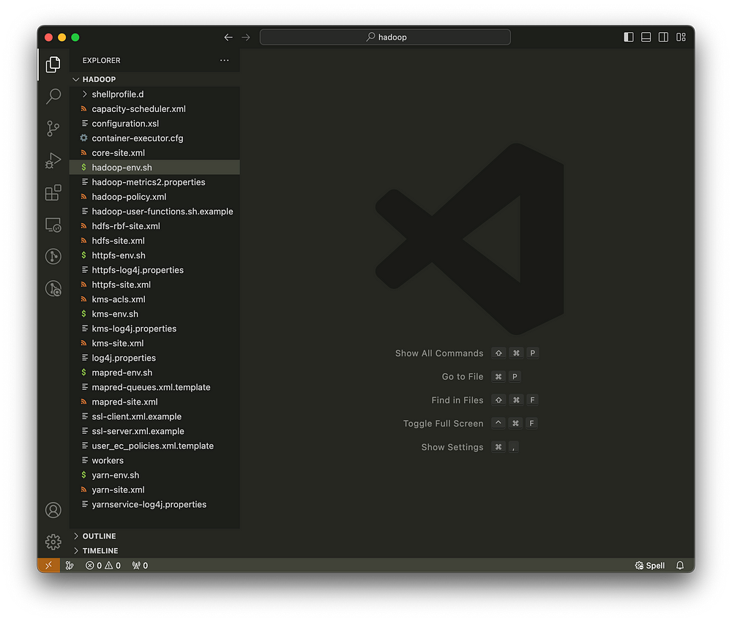

*Get Java home path using below command:*

/usr/libexec/java_home

# -> FILE 1: hadoop-env.sh

Add the code line to the end of the file and replace the path with your Java home path from your local system

|  |  |
| --- | --- |
| export |  |
| JAVA_HOME=/Library/Java/JavaVirtualMachines/adoptopenjdk-8.jdk/Contents/Home | |

Following are file names and code to add to configure hadoop:

# -> FILE 2: core-site.xml

<configuration>

<property>

<name>fs.defaultFS</name>

<value>hdfs://localhost:9000</value>

<final>true</final>

</property>

</configuration>

# -> FILE 3: hdfs-site.xml

<configuration>

<property>

<name>dfs.replication</name>

<value>1</value>

</property>

</configuration>

# -> FILE 4: mapred-site.xml

<configuration>

<property>

<name>yarn.app.mapreduce.am.env</name>

<value>HADOOP_MAPRED_HOME=/opt/homebrew/opt/hadoopp</value> </property>

<property>

<name>mapreduce.map.env</name>

<value>HADOOP_MAPRED_HOME=/opt/homebrew/opt/hadoop</value> </property>

<property>

<name>mapreduce.reduce.env</name>

<value>HADOOP_MAPRED_HOME=/opt/homebrew/opt/hadoop</value>

</property>

</configuration>

# -> FILE 5: yarn-site.xml

<configuration>

<property>

<name>yarn.nodemanager.aux-services</name>

<value>mapreduce_shuffle</value>

</property>

</configuration>

Also, Now open **System Preferences** and open Sharing and select Remote Login

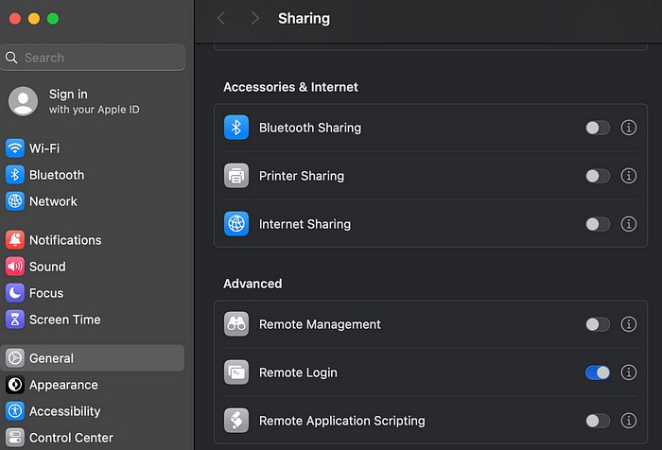

**Step 5: Format HDFS and Start Hadoop**

Run following commands to start hadoop: hadoop namenode -format

*Start hadoop:*

start-all.sh

*You can stop hadoop by using command :* ***stop-all.sh***

*If Error:* [*Hadoop*](https://stackoverflow.com/questions/48978480/hadoop-permission-denied-publickey-password-keyboard-interactive-warning)[*“Permission*](https://stackoverflow.com/questions/48978480/hadoop-permission-denied-publickey-password-keyboard-interactive-warning)[*denied*](https://stackoverflow.com/questions/48978480/hadoop-permission-denied-publickey-password-keyboard-interactive-warning)[*(publickey,password,keyboard-interactive)”*](https://stackoverflow.com/questions/48978480/hadoop-permission-denied-publickey-password-keyboard-interactive-warning)[*warning*](https://stackoverflow.com/questions/48978480/hadoop-permission-denied-publickey-password-keyboard-interactive-warning)

Proceed with the following steps:

1. Generate new keygen.

ssh-keygen -t rsa -P '' -f ~/.ssh/id_rsa 2. Register key gen: cat ~/.ssh/id_rsa.pub >> ~/.ssh/authorized_keys

*You can start hadoop by using command :* ***start-all.sh***

We can verify if all processes are running in machine using this command.

jps

[***http://localhost:9864***](http://localhost:9864/)

[***/***](http://localhost:9864/)

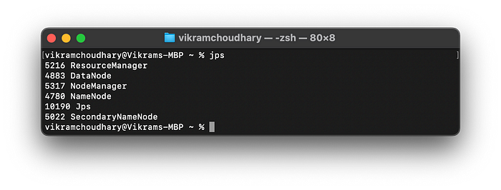

[***http://localhost:8088/cluster***](http://localhost:8088/cluster)

**RESULT:**

The step-by-step installation and configuration of Hadoop on Mac system have been successfully completed.